2022 Annual Report

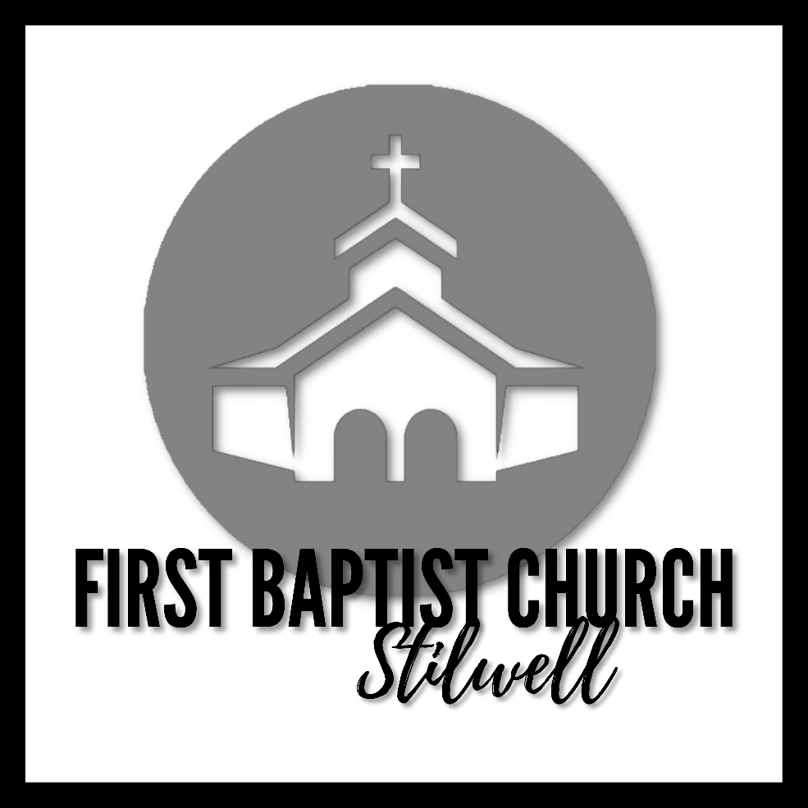

19950 Broadmoor Lane
Stilwell, KS 66085
913-897-2261

Teaching Pastor, Rev. Franklin Ruff
Administrative & Worship Pastor, Rev. Jessica Henks

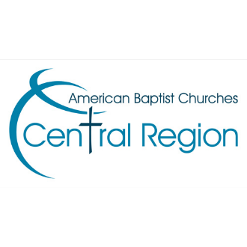
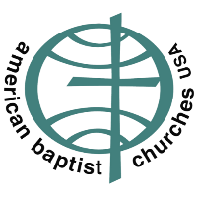
In obedience to the will of God, the First Baptist Church of Stilwell, as part of the Body of Christ, shall be faithful and growing family, sharing God’s love with all people as led by the Holy Spirit.

2022 ANNUAL REPORT
FIRST BAPTIST CHURCH OF STILWELL

TABLE OF CONTENTS

Minutes from previous meeting Page 3
Pastor Franklin’s Report……………………………………………………………………. Page 4
Pastor Jessica’s Report…………………………………………………………….……..… Pages 5-7
Fellowship Committee Report………………………………………………………….. Page 8
Caring Ministry Report……………………………………………………………………… Page 9
Trustee Report………………………………………………………………………………….. Page 10
Memorial Fund Report………………………………………………………………………. Page 11
Nominating Committee Report…………………………………………………………. Page 12
Financial Report..………………………………………………………………………………. Pages 13-18
Proposed Budget 2023……………………………………………………………………… Pages 19-22

Scheduled Quarterly Business Meetings 2023:
1st Quarter: April 16th
2nd Quarter: July 9th
3rd Quarter: October 8th
Meeting to approve Budget & Nominating Report (if not already): Dec. 17th (or earlier)
Annual Meeting: January 28, 2024

First Baptist Church of Stilwell

Special Business Meeting 4/3/2022
Quorum Present

Ed Clark made a motion from the Trustee Board to have a scrub and seal performed on the parking lot for $8,000.00. Bid in hand. The striping was decided would be done separately. After discussion, Erin Lyon seconded the motion. Motion carried, meeting was adjourned.

Informational Meeting 12/4/2022
No quorum present
Pastor Jessica opened meeting
Financial Report was handed out for the year through Dec. 4th, and the floor was opened for questions.
The Proposed Budget for 2023 was handed out with the understanding that it was not finalized as salaries still had to be addressed.
A printed Trustee Report was handed out as received from Ed Clark.
Pastor Franklin also offered thanks to Ed Clark, Marvin Read, and others who have helped to do repairs and upkeep at the parsonage.
Pastor Jessica addressed the issue of Nominating for 2023. We have two positions open for 2023 that need to be filled: Clerk and Moderator.
Gail Dunker volunteered to fill the Clerk position from the floor.
Mark Dunker volunteered to be a helper as needed for the Trustees.
Moderator was left open.
It was discussed that a Bylaws proposal would be put before the congregation by the end of January 2023. This would simply be a place for starting discussion for new bylaws.
Pastor Franklin spoke about the desire to have open lines of communication with the church, and the importance to the Pastoral staff of transparency with the congregation.
An anonymous volunteer donated money to provide poinsettias for the month of December, so those would be picked up by Pastor Jessica and delivered to the church.
With all business being addressed, Pastor Jessica then closed the meeting.

Teaching Pastor’s Annual Report 2022
A large part of the focus for the pastoral team over the past year has been on identifying some of the areas within the church that might be open to attack from the enemy. After identifying those areas, we have been concentrating on ways to strengthen the church. This process is ongoing as we move into 2023. For the easter season we move Maundy Thursday to Good Friday and combined the two services. Over the past year we have changed our Sunday school curriculum moving to David C. Cook. We had three major series this year. We started with a series on praying for vision. Our second series was on the prophet Elijah, and our final major series was an examination of Difficult Scriptures
I have continued to be led by the Holy Spirit as I deliver Sunday sermons. I also continue to disciple individuals and encourage them in their walk with Christ. Pastor Jessica and I continue to strengthen our ability to work as a team. I continue to work on my PhD in preaching in order improve my skills as a preacher and pastor. I continue to build and maintain relationships in the community. My family and I showed our support for our firefighters on behalf of ourselves and our church family by delivering cookies to local fire departments on Christmas day.
We did not have any baptisms in 2022. We are in a community where the field may be ripe for the harvest, but first the workers must be ready. This year we will work on the workers. We started the process of addressing needed changes in our constitution. This process continues.
As we move into 2023, I look forward to seeing what God will do in the next year. We will continue to focus on prayer and on growing spiritually. We will focus on service, growing God’s people and carrying the Word of God to the lost. We have three series planed for the coming year, they are Church Leadership, James, and Amos. We will also take some time to look at a few Psalms and Proverbs.

Sincerely
Franklin M. Ruff
Franklin M. Ruff
Teaching Pastor, First Baptist Church Stilwell, Kansas

Annual Report 2022
Rev. Jessica Henks – Administrative & Worship Pastor

What a joy and privilege it has been to continue to serve First Baptist Church of Stilwell. With each passing year, I grow to love and appreciate this local body of Christ more and more. I pray that 2023 will bring greater depth and fruit as we move into another year. Thank you for the opportunities to build relationships, serve alongside you, bear witness to the ups and downs of your lives, laugh, cry, and pray together. It has been a great joy this year to get to spend increased time with your children and youth. They are wonderful young people with a curiosity for God and a joyful spirit.

This past year, I have kept busy wearing a number of different hats serving the congregation. In January, we began hosting Silo Community Church on Saturdays. I invested time helping them move into our space, orienting to worshipping here, and offering help where I could to help them bear Kingdom fruit. I am not sure that you all could see all of the Kingdom work that you did in that sharing of physical space. One day, Pastor Adams’ oldest daughter stopped me in the hall, and with tears in her eyes, she explained that over the years as a missionary and pastor’s daughter, she had seen a lot of churches and ministries…but never had she seen Christians who were so welcoming, so willing to do God’s work without a competitive spirit…never had she felt so at home…and so loved. I experienced similar stories again and again over the past year from those who attended Silo’s services and were a part of their ministry team. The simple act of sharing with open hands what we have with those who don’t have…with the shared vision of doing God’s work…it produces fruit. Silo has moved to the Elementary School because they needed a Sunday morning worship time, but will still use our building some for midweek activities. Your generous hospitality matters. Thank you.

To state the obvious…I have continued to work with the praise team to bring music to the worship service. I appreciate each of them and their desire to worship God. Thank you. We have added Wesley and Parker to the team with Brian and Gail upstairs this year. They are learning and doing well, again “Thanks”! We continue to work to hone the technology aspects of worship. There are certain realities with technology that always bring about frustration, but we continue to make adjustments and do what we can. I appreciate those who bring constructive comments to me about what you need to worship well...when you aren’t hearing voices well, when the livestream is consistently failing, etc. I know that we all have preferences…and I can’t meet every need. However, it is helpful to know if there are things significantly effecting our ability to worship so that we can try to make adjustments and make things better. I have been working this last year to hone my worship piano skills more…it has taken some time to get comfortable playing piano and singing…and making the shift from classical piano to the worship format…but we are making progress. I really appreciate all our musicians, and special thanks to those who have intentionally trained across multiple instruments to help fill gaps when they arise. You are all appreciated.

It is my great joy to preach in worship as the opportunity arises. I appreciate Pastor Franklin’s willingness to share that space and let me share my gifts and passion there. I truly enjoy getting to unpack God’s word with the church, and preaching has long been a passion for me.

At the end of February, I picked up Youth and Family ministry. I have been meeting weekly with the youth for their youth group times, and we have been enjoying our time together. We have undertaken and number of different studies this past year, including Revelations, Hebrews, some Church History, Understanding World Religions as they compare to Christianity and how to talk to people of other faiths, and some basic Theology. In 2023, we are planning a service trip to Murrow and hopefully a Quest trip this summer. On Sundays, I am working with the children in children’s church. Nancy Rains, teaching elementary age Sunday School, and I are cooperating on a curriculum to work the children through the major bible stories in one year. I have worked with Nancy, Angela, and Helen to address the Sunday School/children’s church needs of our children. Nancy and Helen picked up Sunday School for Elementary and Middle/High School classes in March. They are doing a great job! Thank you ladies!

In my capacity as Administrative Pastor, I continue to work with leaders and boards of the church to care for the building, address financial questions and needs, make decisions about care for the physical plant and participation/communication in the community. I organize building usage, work with Sandra on office management, and oversee general functioning. I won’t go into too many details about that, sufficed to say, there are plenty of pieces to keep me busy there. I also continue to work with the cluster in our area, organizing meetings for our pastor group.

We have undertaken several relational and ministry opportunities in 2022. In March, we hosted Ash Wednesday services with the youth, in April, the Easter Egg Hunt and Stations of the Cross along with Good Friday services. In the spring, we also participated in the Numana Event at the Methodist Church. At the end of June we hosted a week long VBS with a great turn out, and on July 4th we participated in the parade. In July, I also took kids to camp for Middle and High School camps. In September, we had our back to school picnic. In October, we hosted our second annual women’s retreat: Waymaker. November brought our Thanksgiving Dinner, which was great. And of course, December, our Christmas Eve services and concert (which thanks to COVID, I missed).

I have continued to work with Donna and all of our wonderful volunteers in the Caring Ministry. It is a great joy to get to know them and serve alongside them as we meet needs in our community. I have continued to work to know the volunteers and the system of the Caring Ministry so that as needed, I can fill in for Donna. Our ability to serve and be present to the community through the Caring Ministry is vital. I have had so many opportunities to serve and connect to the larger community through that ministry, and have heard so many talk about it in positive and significant ways. Thank you to all who serve there.

Over the year, I have maintained a varied counseling schedule. Sometimes carrying multiple appointments a week, and at other times a much lighter schedule. I do have gifts for counseling, particularly with those battling depression and anxiety. So, as the Lord brings me individuals, I do take on regular counseling.

Just as a note and a matter of information, I do also serve as Webmaster and Technology coordinator for the American Baptist Women’s Ministry of the Central Region. I sit on the Executive Board in that capacity and work to continue that ministry of service and mission. In addition, in 2023, I am launching a new ministry…which will manifest itself at FBC, but also throughout the region called “Rooted”. This is a discipleship ministry to women. It is in its infancy, but has great potential. I will be opening these opportunities to our congregation and community, but also broader as we seek to deepen relationships with God throughout our sphere of influence.

As always, I invite conversation and reflection. I encourage you to reach out if you have questions or concerns about the church or how ministry is going. I really do love you all, I appreciate you, and I look forward to serving you for whatever season the Lord allows.

Blessings,

Pastor Jessica

Fellowship Committee
2021
The fellowship committee consists of three people. Whenever there is a funeral, we serve a meal if the family requests one, we send flowers to a funeral when they are members or immediate family.
We put a sign-up sheet for lilies at Easter and poinsettias at Christmas. They are ordered and used as church decorations and then given to the person.
Thanksgiving we put a sign-up sheet for turkey and gravy, dressing and mashed potatoes for the dinner the Sunday before Thanksgiving.
We also do “hanging of the greens” to decorate the church for Christmas and then take them down.
We purchase supplies for the kitchen.
~Joyce

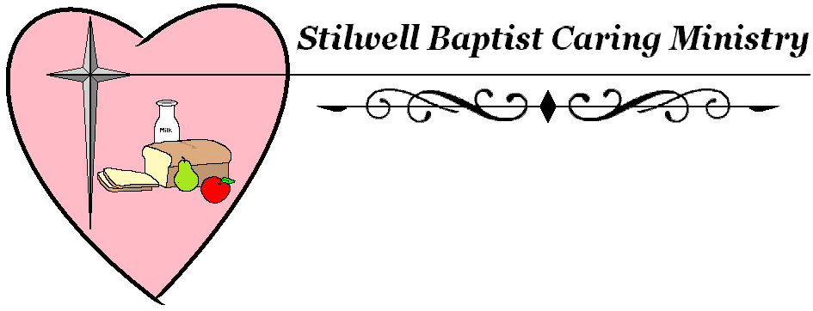

Annual Report - January 1 to December 31, 2022
Again, we all look back to this last year. This has been the year of wild fluctuation! With client high numbers and low numbers, and with food high and low numbers or once no food came in at all. But through all this God is always blessing us and the clients we serve. Let me give you a glimpse of what I mean. Volunteers are always faithful, sure we have an absence or vacation but their heart brings them back. They are givers at heart Our Volunteers gave 11,728 hours, 1,354 volunteers were giving and serving. I just want to add a Thank You to all of them. .
Holiday | Families | Elderly | Adult | Children | Total
Thanksgiving | 475 | 192 | 869 | 625 | 1,686
Christmas | 409 | 158 | 758 | 566 | 1,472

God provides planning for Christmas our prayers were answered in cash, in 7 days were given $7,000. Dollars. So Hy Vee helped us to purchase the meat we needed for Christmas. Thanksgiving was blessed in a different ways, so many families and friends and so many Churches, and even a new school. But the Church of Jesus Christ of Latter Day Saints provide the meat for our clients. Some provide to us on a regular basis and we are blessed with that devotion, there are so many of you. Church of the Resurrection. They have given us can goods on a regular basis and money to spend at Harvesters to order things we need.
We were blessed with support from friends and neighbors that bring from their pantries, gardens, and hearts for the clients we serve. We have about 25 churches and organizations helping us with this challenge. We have also been blessed by doing grocery store rescue, working with Hy-Vee, Price Chopper, Walmart, Target, Sprouts. A Thank You to all who give.
So Just a Few Facts:
People | Year | Food/Pounds
85,584 | 2021 | 1,601,645
81,302 | 2022 | 1,089,870
166,886 | Total | 2,691,515
Our numbers show that we were just marginally smaller. From last year to this year. But it is like the story of the starfish, what did we mean to that one we served. Let us continue to serve in His Name.
Trustee Report 2022

- Sealed parking lot and placed new parking lines.
- Removed old floor in fellowship hall and replaced with new chip surface.
- The following repairs were done at the parsonage:
  - New garbage disposal
  - Replaced wall plug
  - Videoed waste line from house to septic tank and found small blockage and repaired it.
  - Replaced roof
  - Installed egress window in basement bedroom.
  - Installed door in basement bedroom.

- Other items repaired or replaced too numerous to mention.
- All the above was done with help from: Marvin, Dave, and Ron.

Memorial Fund Report 2022

Date Transaction Balance
1/1/2022 Starting Balance $1,851.58
6/21/2022 Deposit $600.00 $2,451.58
6/23/2022 Check – Tree Service $1,800.00 $651.58
6/28/2022 Check – Tree Service $300.00 $351.58
7/20/2022 Service Charge $10.00 $341.58
8/20/2022 Service Charge $10.00 $331.58
9/9/2022 Acct moved to First National Bank $331.58
9/10/2022 Deposit $300.00 $631.58
9/11/2022 Deposit $580.00 $1,211.58
9/20/2022 Withdrawal for checks - $27.00 $1,184.58
9/26/2022 Deposit - $25.00 $1,209.58
10/20/2022 Deposit – $138.00 $1,347.58
12/31/2022 Ending Balance $1,347.58

Nominating Committee Report
Proposed Slate of Officers for 2023

Moderator:________________________________
Clerk: Gail Dunker

Board of Deacons:
- Russ Rogers
- Dave Read
- Brad Rolfs

Board of Trustees:
- Ed Clark
- ______________________________
Board of Christian Education:
- Angela Forster*
- Nancy Rains

Worship Committee:
- Gail Dunker
- Mark Dunker

Fellowship Committee:
- Evelyn Dooling
- Joyce Read
- Susan Boydston

Head Usher:
- Dave Read

Treasurer:
- Leslie Wilson
- Marvin Read

Assistant Treasurer
- Debbie Read

Finance Committee:
- Marvin Read
- Leslie Harshaw

Nominating Committee
- Helen Angermayer

